BENEFIT AUCTION
CHILI~ IVARS CHOWDER~SALAD
Saturday Nov 14 From 4 to 8 PM
Stanwood American Legion
$10 or DONATION item or service

Proceeds go to Staff Sergeant Matt Murphy & Family

I am A Guardian of Freedom and the American way of life,

I am an American Soldier ~ From Soldier’s Creed

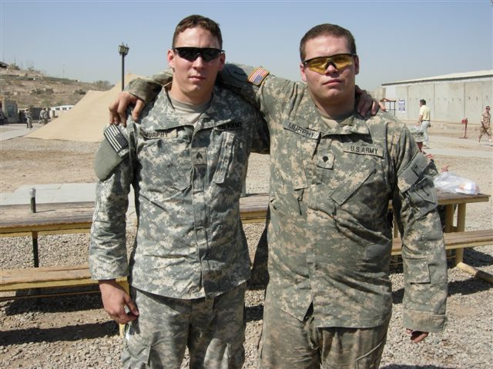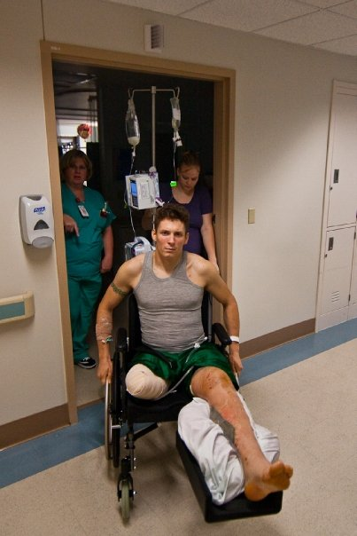 Matt & brother James, Iraq 2008 Sgt Matt Murphy Connor, Matt, Rylee, Kalah

On September 14 while serving his country in Afghanistan,
Matt lost his right leg and sustained severe injuries to the other. He & his family are now required to relocate to Texas for rehab & recovery. These proceeds will help with ongoing expenses over the next 2 years. Matt is the great grandson of long time Camano Island residents Evangeline “Vangie” & Maurice “Spud” Murphy.

Donations can be made at any Bank of America branch. Account #586016330644
Lorri 425-268-7283 Joe 425-870-6116
Richard 360-387-4840

