DONATION REQUEST

BENEFIT AUCTION
Saturday Nov 14 From 4 to 8 PM
Stanwood American Legion
On Sept 14 while serving his country in Afghanistan, Matt lost his right leg and sustained severe injuries to the left leg. He & his family are now required to relocate to Texas for rehab & recovery. These proceeds will help with ongoing expenses over the few years. Matt is the great grandson of long time Camano Island residents Evangeline “Vangie” & Maurice “Spud” Murphy.

All Proceeds go to Staff Sergeant Matt Murphy & Family

I am A Guardian of Freedom and the American way of life ,I am an American Soldier

~ From Soldier’s Creed

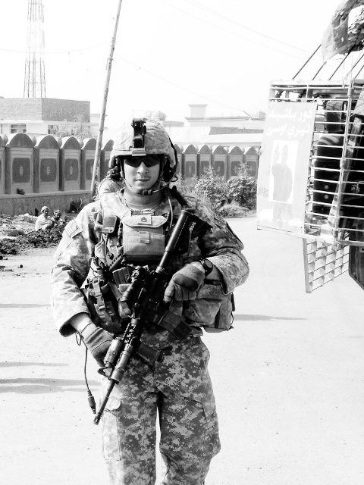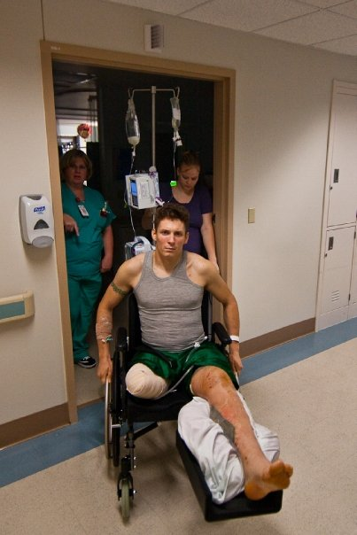

Sgt Matt Murphy Connor,Matt,Rylee,Kalah, Sgt Matt Murphy

Company Name________________________________

Item & Description______________________________

Items Value_______________________

Date of Pick or Delivery_____________

Contact Person ___________________

Contact Phone____________________
Donations can be made at any Bank of America branch. Account #586016330644
Lorri 425-268-7283 Joe 425-870-6116
Richard 360-387-4840

